A

Technical Report

On

**POWER PRODUCTION STYSTEM THROUGH THE APPLIED FORCE**

*Submitted to CMR Institute of Technology in the partial fulfillment of the requirement of*

**Social Innovation Lab**

Of

**II B.Tech I- Semester**

in

**ECE DEPARTMENT**

Submitted by

**M.PRANITHA (20R01A04F5)**

***Under the esteemed guidance of***

*Mr.veeresh*

*Assistant Professor*



**CMR INSTITUTE OF TECHNOLOGY**

**(UGC-AUTONOMOUS)**

(Approved by AICTE, Permanently Affiliated to JNTU Hyderabad, Accredited by NBA, Accredited by NAAC with A Grade)

Kandlakoya (V), Medchal Road, Hyderabad  501 401

**2021-2022**

***Department of ECE***

**Certificate**

This is to certify that the technical report entitled“***POWER PRODUCTION SYSTEM THROUGH THE APPLIED FORCE***” is the bonafidework done and submitted by

**M.Pranitha (20R01A04F5)**

towards the partial fulfillment of the requirement of Social Innovation (SIL) Laboratory of **II B. Tech I-Semester** in **ECE** is a record of bonafide work carried out by them during the period **Aug 2021to Dec 2021.**

**Guide Co- Ordinator Head of Department**

***Mr.U.Veeresh Mr.U.Veeresh Dr.K. Niranjan Reddy***

**INDEX**

**Topics**

**CHAPTER-I INTRODUCTION**

**CHAPTER -II Empathize**

**CHAPTER -III Define**

**CHAPTER -IV Ideate**

**CHAPTER -V Prototype**

**CHAPTER -VI Test**

**\*sources and references**

1. **INTRODUCTION**

* **WHAT IS SOCIAL INNOVATION?**

The term ‘social innovation ’once rarely heard is ,now often used to describe a whole variety of things that fall into general categories of being both new and good.It’s understandable that the phrase has become popular-we get excited and hopeful when it seems possible for real change to happen in the world.

Social innovation refers to the Design and implementation of new solutions that imply conceptual ,process ,product or organisational change which ultimately aim to improve the welfare and wellbeing of individual communities

Social innovation is not a new concept and should not be considered similar to other definitions, such as social entrepreneurship, creativity or invention, improvement or change. 'As with innovation in technology or business, social innovation is distinct from ‘improvement’ or ‘change’ and from ‘creativity’ and ‘invention’. These last two are both crucial to innovation but overlook the important stages of implementation and diffusion which make new ideas useful.

* **What is design thinking process?**

Design Thinking is a design methodology that provides a solution-based approach to solving problems. It’s extremely useful in tackling complex problems that are ill-defined or unknown, by understanding the human needs involved, by re-framing the problem in human-centric ways, by creating many ideas in brainstorming sessions, and by adopting a hands-on approach in prototyping and testing. Understanding these five stages of Design Thinking will empower anyone to apply the Design Thinking methods in order to solve complex problems that occur around us — in our companies, in our countries, and even on the scale of our planet.

Design thinking originally came about as a way of teaching engineers how to approach problems creatively, like designers do. One of the first people to write about design thinking was John E. Arnold, professor of mechanical engineering at Stanford University.

**The five stages of design thinking:**

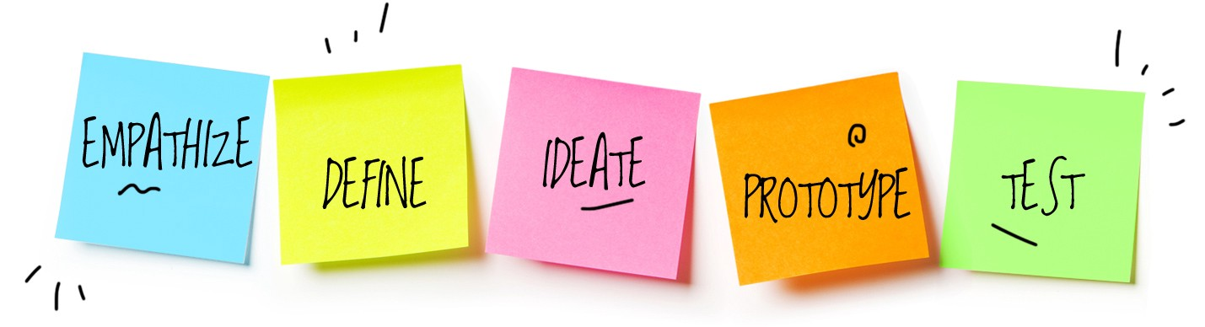

1. Empathize-The Design Thinking process starts with empathy. In order to create desirable products and services, you need to understand who your users are and what they need.
2. Define- In the second stage of the Design Thinking process, you’ll define the user problem that you want to solve.
3. Ideate.-The third stage in the Design Thinking process consists of ideation or generating ideas. ...
4. Prototype- In the fourth stage of the Design Thinking process, you’ll turn your ideas from stage three into prototypes.
5. Test -The fifth step in the Design Thinking process is dedicated to testing: putting your prototypes in front of real users and seeing how they get on.

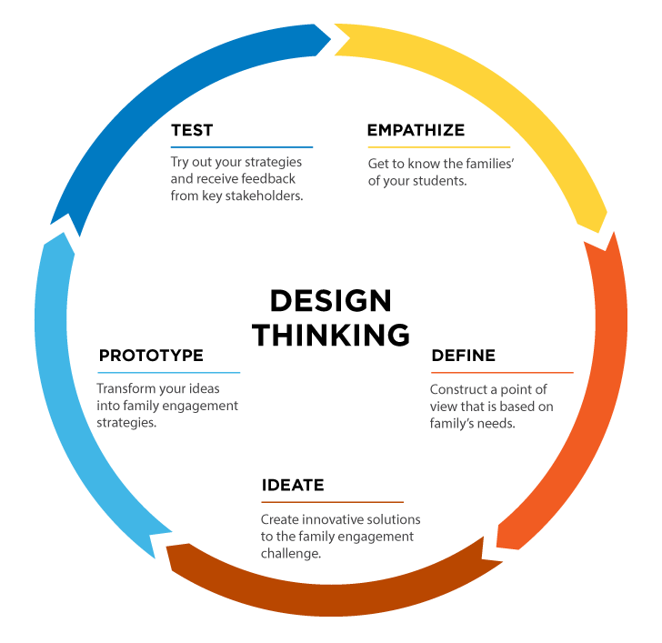**2.Empathize**

The first stage of the Design Thinking process is to gain an empathic understanding of the problem you are trying to solve. This involves consulting experts to find out more about the area of concern through observing, engaging and empathizing with people to understand their experiences and motivations, as well as immersing yourself in the physical environment so you can gain a deeper personal understanding of the issues

involved. Empathy is crucial to a human-centered design process such as Design Thinking, and empathy allows design thinkers to set aside their own assumptions about the world in order to gain insight into users and their needs.

We have collected information from various sources like conducting surveys among the people about their problems as they are facing right now and interviewing people, reading novels from various books ,collecting information from the internet.

As our team has conducted a survey among the people at the current problems they are facing we have got many problems to be listed .In those information we have found many valid problems as they are facing in the day to day life and the collected information have been segregated accordingly.

We have shortlisted few problems which are being affected by the most people in the society .

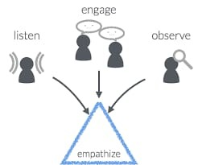

So , have chosen one of the problem that is the power production through the applied force is one of the major problem from the shortlisted problems that many people are facing this problem.

**2.Define**

In this define stage, we have defined the problem statement accordingly to our problem. According to the scenario as we have collected information in the empathy stage we have defined the problem statement as “POWER PRODUCTION THROUGH THE APPLIED FORCE”

**Problem Statement**

Envoronmental issues of electricity production.The various of fuels used to generate electricity all have some impact on the environment.Fossil fuel power plants release air pollution,require large amount of cooling water,and can mar large tracts of land during the mining process.

**ADVANTAGES AND DISADVANTAGES OF POWER PRODUCTION THROUGH THE APPLIED FORCE**

**ADVANTAGES:-**

1.Power generation is simply walking on step.

2.no need of fuel input.

3.this is non-conventional system.

4.No moving parts hence long service life.

5.Compact and highly sestive.

**DISADVANTAGES:-**

**1.only applicable for the particular place.**

**2.initial cost ofthis arrangement is high.**

**3.output affected by temperature variation.**

**APPLICATIONS:-**

**1.Foot step generated power can be used for,agriculture,home applications,street lighting.**

**2.Foot step power generation can be used in emergency power failure situations.**

**3.Metros and rural application.**

**3.Ideate**

In this design thinking process we have ideate as the next stage and we have come up with a solution according to the above problem statement as we have mentioned In this design thinking process we have ideate as the next stage and we have come up with a solution according to the above problem statement as we have mentioned.

Piezois are connected series or and parallel combination.

All the positive jumper wires are connected to positive side of the batteryand negative wires are connected negative side of the battery

Positive jumper wires of pizeos sensor are connected 3 voits of aurdino uno.

Negetive jumper wires of piezos are connected to the ground of arduino uno.

Positive terminal of the battery is connected to 5 volts of aurdini

Negative terminal of the battery is connected to ground of the aurdino uno.

For checking purpose cable connected to mobile.

**4.prototype**

The next step is making a prototype , that is for making a prototype we require components like

**COMPONENTS REQUIREMENTS :-**

1) piezos.

2)LCD.

3) Rechargable battery .

4) PCB(printed circuit board) .

5) Arduino UNO.

6) Jumper wires.

7) Relay .

**TOTAL COST OF OUR PROJECT IS =Rs 1700\-**

piezo sensors:-

piezo sensors are used within many sensors and devices.they used to convert a physical parameter.piezoelectric force sensors are low impedance voltage force sensors.

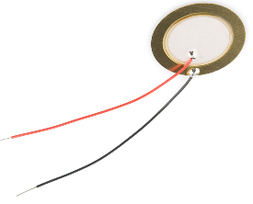

(ii)  **LCD :-**

A liquid-crystal display is a flat-panel display or other electronically modulated optical device that uses the light-modulating properties of liquid crystals combined with polarizers. Liquid crystals do not emit light directly, instead using a backlight or reflector to produce images in color. 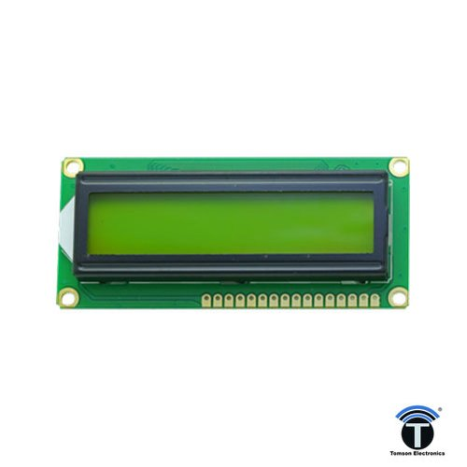

(iii)  **RECHARGABLE BATTERIES:-**A battery is a source of electric power consisting of one or more electrochemical cells with external connections for powering electrical devices such as flashlights, mobile phones, and electric cars.

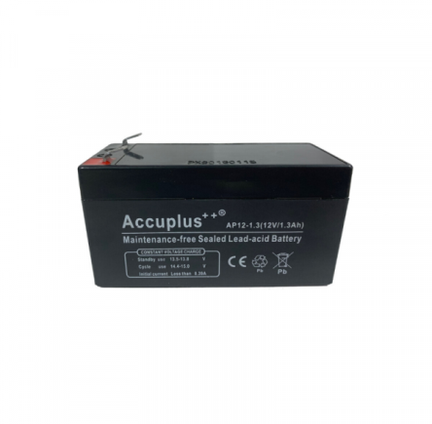

**(iv)RELAY**

A relay is **an electrically operated switch**. ... Relays were first used in long-distance telegraph circuits as signal repeaters: they refresh the signal coming in from one circuit by transmitting it on another circuit. Relays were used extensively in telephone exchanges and early computers to perform logical operations. 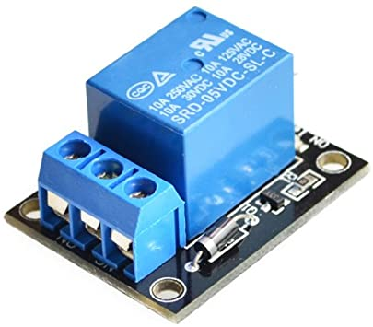

PCB:-

* PCBs mechanically support [electronic components](https://en.wikipedia.org/wiki/Electronic_components" \o "Electronic components) using [conductive](https://en.wikipedia.org/wiki/Electrical_conductor" \o "Electrical conductor) pads in the shape designed to accept the component's terminals, and also electrically connect them using traces, planes and other features [etched](https://en.wikipedia.org/wiki/Industrial_etching" \o "Industrial etching) from one or more sheet layers of copper [laminated](https://en.wikipedia.org/wiki/Laminated" \o "Laminated) onto and/or between sheet layers of a [non-conductive](https://en.wikipedia.org/wiki/Insulator_(electricity)" \o "Insulator (electricity)) substrate.

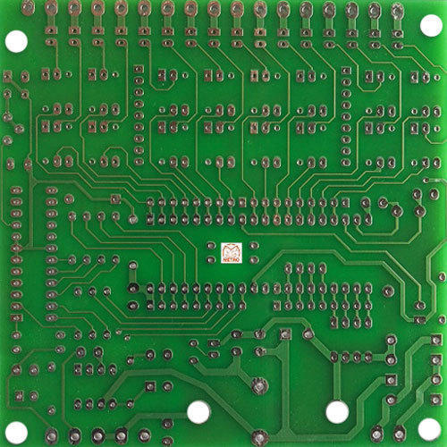

**(VI) JUMPER WIRES:-** A **jump wire** (also known as jumper, jumper wire, jumper cable, DuPont wire or cable) is an [electrical wire](https://en.wikipedia.org/wiki/Electrical_wire" \o "Electrical wire), or group of them in a cable, with a connector or pin at each end (or sometimes without them – simply "tinned"), which is normally used to interconnect the components of a [breadboard](https://en.wikipedia.org/wiki/Breadboard" \o "Breadboard) or other prototype or test circuit, internally or with other equipment or components, without soldering.[[1](https://en.wikipedia.org/wiki/Jump_wire" \l "cite_note-1)

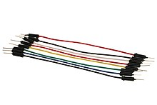

**(VIII) Arduino Uno:-**

**Product Description:** Arduino is an open source computer hardware and software company, project, and user community that designs and manufactures single-board microcontrollers and microcontroller kits for building digital devices and interactive objects that can sense and control objects in the physical world. The boards are equipped with sets of digital and analog input/output (I/O) pins that may be interfaced to various expansion boards (shields) and other circuits. The boards feature serial communications interfaces, including Universal Serial Bus (USB) on some models.

The microcontrollers are typically programmed using a dialect of features from the programming languages C and C++.

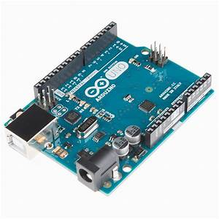

**SOURCE CODE**

//Program to

**#include <LiquidCrystal.h>**

**LiquidCrystal lcd(2,3,4,5,6,7);**

**void setup()**

**{**

**// Debug console**

**Serial.begin(9600);**

**pinMode(8,OUTPUT);**

**digitalWrite(8,LOW);**

**pinMode(9,OUTPUT);**

**digitalWrite(9,LOW);**

**lcd.begin(16,2);**

**lcd.print("VOLTAGE ");**

**lcd.setCursor(0,1);**

**lcd.print(" MONITORING");**

**delay(2000);**

**lcd.clear();**

**}**

**void loop()**

**{**

**int aa=analogRead(A0);**

**int t=aa\*(500/1023.0);**

**int a=analogRead(A1);**

**float v=a\*(2.8/(4095.00))\*35;**

**String s="V:"+String(v);**

**lcd.setCursor(0,0);**

**lcd.print(s);**

**if(t>55 || v>9)**

**{**

**digitalWrite(8,LOW);**

**digitalWrite(9,HIGH);**

**lcd.setCursor(0,1);**

**lcd.print("NO CHARGING");**

**}**

**else**

**{**

**digitalWrite(9,LOW);**

**digitalWrite(8,HIGH);**

**lcd.setCursor(0,1);**

**lcd.print("CHARGING ");**

**}**

**delay(1000);**

**}**

**DIAGRAM:**

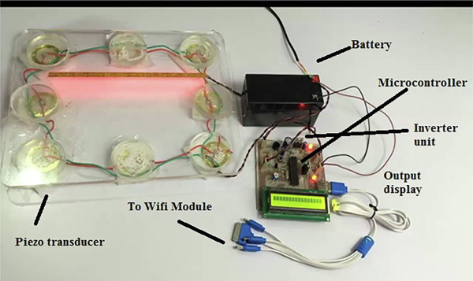

**5.test**

Designer or evaluator rigorously test the complete product using the best solutions identified during prototype phase.we have tested several times by connecting LED.

Testing is often undertaken concurrently with prototyping and performed well ,it can provide many learning oppurtunitiesto help ypu learn more about user ,and opportunities to refine your and even the problem statement

we have also found errors in uploading the code to the arduino that it is showing compile error. we didn't include the library files to code.so, we installed the libraray file named <servo.h> in the ardunio software .Then code complied succesfully and done uploading.

Testing the setup ‘n’ number of times will make us to clear all the loop holes which are in it . And the final product efficient and its performance is be good and considerable and other working models.

And while uploading the code make sure you are connected to the port and upload it using the rightarrow.

**REFERENCES:-**

* *.* *<https://www.worldcat.org/oclc/824752425>*
* *[1] International Research Journal of Engineering and Technology (IRJET) [www.irjet.com](http://www.irjet.com/).*
* *[2] Design Study of Piezoelectric Energy- Harvesting Devices for Generation of Higher Electrical Power Using a Coupled Piezoelectric-Circuit Finite Element Method IEEE Transactions on Ultra Sonics, Ferroelectrics, and Frequency Control, vol. 57, no. 2, February 2010.*
* *[3] “Pavegen plan to power world through pavegen Technology” –based on electro magnetic induction.. https:/pavegen.com*